COS 226 Algorithms and Data Structures Fall 2010

Midterm Solutions
1. Analysis of algorithms.
(a) For each expression in the left column, give the best matching description from the right
column.

B. 1+2+4+8+ ... + N ∼ 2N
C. 1+2+3+4+ ... + N ∼ 12 N2
B. 1+3+5+7+ ... + N ∼ 14 N2
C. 12 N2 1
C. N2 + 100N lg N
2
B. N2
D. N3 A. ∼ 12 N2 .
B. O(N2).
C. Both A and B.
D. Neither A nor B.

(b) For each quantity in the left column, give the best matching description from the right
column.

B. Height of a weighted quick union data structure with N items.
C. Height of a binary heap with N keys.
A. Height of a left-leaning red-black BST with N keys.
C. Maximum function-call stack size when (top-down) mergesorting N keys.
A. Maximum function-call stack size when quicksorting N keys.
B. Number of compares to binary search in a sorted array of size N.
A. ∼ lg N in the best case.
B. ∼ lg N in the worst case.
C. Both A and B.
D. Neither A nor B.
(c) 2 minutes.
1 N2
The order of growth of the running time is N2 log N from the ∼ calls to binary
2
search. Thus, if the problem size increases by a factor of 10, the running time will increase by a bit more than a factor of 102 .
(d) 40 bytes (using 32-bit cost model from Intro to Programming).
(8 bytes of object overhead, 4 bytes for the int, and 4 bytes for each of the 7 references) 88 bytes (using 64-bit cost model from Algorithms, 4th edition). (16 bytes of object overhead, 8 bytes of inner class overhead, 4 bytes for the int, and 8 bytes for each of the 7 references, 4 bytes of padding)
2. 8 sorting algorithms. 0576439281
3. Binary heaps.
(a)
(b)
(c)
4. Red-black BSTs.
(a) H,I,J,andK
(b) RED
(c)
5. Hashing.
6. Bitonic max.

0 | 1 | 2 | 3 | 4 | 5 | 6 | 7 | 8 | 9 | 10 | 11 | 12
- | Y | W | M | G | U | K | C | A | F | H | P | -

0 | 1 | 2 | 3 | 4 | 5 | 6 | 7 | 8 | 9 | 10 | 11 | 12
- | W | U | M | G | P | K | C | A | F | H | - | -

0 | 1 | 2 | 3 | 4 | 5 | 6 | 7 | 8 | 9 | 10 | 11 | 12
- | Y | W | Q | G | U | M | C | A | F | H | P | K

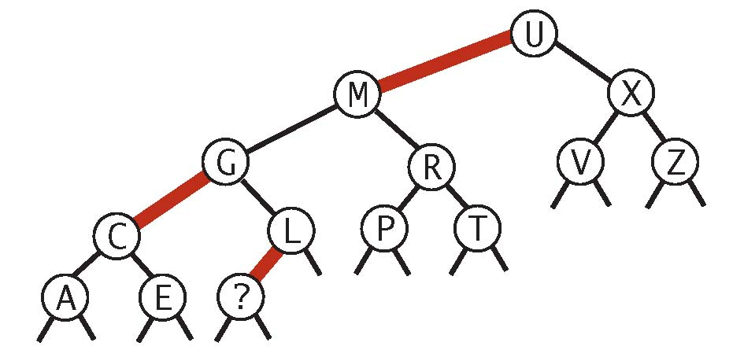
0 | 1 | 2 | 3 | 4 | 5 | 6
G | B | D | A | C | E | F

(a) We use a binary-search like algorithm, where we compare the middle key to the neighboring key to its right. Depending on the result of the comparison, we recur in the left subarray or the right subarray (which is also bitonic).
// find the max in the bitonic subarray a[lo] to a[hi]
public static int max(int[] a, int lo, int hi) { if (hi == lo) return a[hi]; int mid = lo + (hi -lo) / 2; if (a[mid] < a[mid+1]) return max(a, mid+1, hi); else if (a[mid] > a[mid+1]) return max(a, lo, mid); else return a[mid];
}
We maintain the invariant that the subarray contains the maximum key. At each step, the size of the subarray decreases by a factor of 2, so the number of compares is logarithmic in N.
(b) Here are the ﬁrst four compares when ﬁnding the maximum of the following bitonic array:
i | 0 | 1 | 2 | 3 | 4 | 5 | 6 | 7 | 8 | 9 | 10 | 11 | 12 | 13 | 14
a[i] | 10 | 34 | 56 | 76 | 87 | 80 | 70 | 66 | 56 | 30 | 28 | 25 | 20 | 15 | 11

- compare a[7] to a[8] (66 to 56)
- compare a[3] to a[4] (76 to 87)
- compare a[5] to a[6] (80 to 70)
- compare a[4] to a[5] (87 to 80)

7. Stable priority queue. Binary heap solution. The basic idea is to associate the integer timestamp i with the ith key that is inserted into the priority queue. To compare two keys, compare their keys as usual; if they are equal, break ties according to the associated timestamp. This ensures that
if there are two equal keys, the one that was inserted ﬁrst is considered smaller than the one that was inserted last. Here are two ways to implement this approach in Java.
• Implementation 1. We modify our standard MinPQ implementation as follows:
– Associate the integer timestamp i with the ith key that is inserted by creating a nested class StableKey.
private class StableKey { private Key key; private long timestamp;
public int compareTo(StableKey that) { int cmp = this.key.compareTo(that.key); if (cmp < 0) return -1; if (cmp > 0) return +1; return this.timestamp -that.timestamp;
} }
– When comparing two keys in less(), break ties according to the timestamp ﬁeld using the compareTo() method above.
• Implementation 2. We modify our standard MinPQ implementation as follows:
- Associate the integer timestamp i with the ith key that is inserted by adding a parallel array long[] timestamp as an instance variable of StableMinPQ.
- Modify exch() so that whenever it exchanges pq[i] with pq[j], it also exchanges timestamp[i] with timestamp[j].
- Modify less() so that it breaks ties according to timestamp[].

Binary search tree solution. An alternate solution is to use a red-black BST. Some care is needed because our implementation of RedBlackBST does not support duplicate keys without modiﬁcation. To handle duplicate keys, we declare a RedBlackBST<Key, Queue<Key>>, where the value is a queue of all the keys equal to the key.
- To insert a key, we check if there is a key equal to it already in the BST. If there is, we add the key to the corresponding queue; if there is not, we add the key to the BST ﬁrst.
- To delete the minimum key in the stable priority queue, we call min() to ﬁnd the minimum, and return the ﬁrst element of corresponding queue. We don’t invoke the delMin() method of RedBlackBST unless the queue becomes empty.

Wrong solution. A tempting idea is to swap equal keys during sink() but not to swap equal keys during swim(). However, the following sequence of operations discredits this approach:
- insert C1
- insert B1
- insert A
- insert B2
- insert C2
- delmin (returns C1)
- delmin (returns C2)
- min (returns B2 instead of B1)

